Subject: Software Requirements
Title: Progress Test 3
Content: Chapter 9,10,11,12
Time: 30’
Number of question: 32/55

QN=1 | Obstacle analysis is a ______ of risk analysis aimed at identifying, assessing and resolving the possibilities of breaking assertions in the system’s goal mod
a. | assertion-based form
b. | goal-based form
c. | obstacle-based form
d. | requirement-based form
e.
f.
ANS: | B
PTS: | 1
CHAPTER: | 9
MIX CHOICES: | YES

QN=2 | An obstacle is a pre-condition for ______ of some goal, hypothesis or questionable domain property used in the goal model.
a. | satisfaction
b. | non-satisfaction
c. | Weakness
d. | Divergent
e.
f.
ANS: | B
PTS: | 1
CHAPTER: | 9
MIX CHOICES: | YES

QN=3 | Goals and obstacles are dual notions. Therefore, we can derive obstacle categories from _____.
a. | Goals
b. | Goal model
c. | Goal categories
d. | Goal obstructions
e.
f.
ANS: | C
PTS: | 1
CHAPTER: | 9
MIX CHOICES: | YES

QN=4 | In obstacle diagram, leaf obstacles are connected to countermeasure goals through __________.
a. | Responsibility links
b. | Realizability links
c. | Feasibility links
d. | Resolution links
e.
f.
ANS: | D
PTS: | 1
CHAPTER: | 9
MIX CHOICES: | YES

QN=5 | Goal obstruction propagates _______ along goal AND-refinement trees
a. | top-down
b. | bottom-up
c.
d.
e.
f.
ANS: | B
PTS: | 1
CHAPTER: | 9
MIX CHOICES: | YES

QN=6 | not (if A then B) amounts to:
a. | not A and not B
b. | A and not B
c. | not A and B
d. | not A or not B
e.
f.
ANS: | B
PTS: | 1
CHAPTER: | 9
MIX CHOICES: | YES

QN=7 | Like in any risk management process, obstacle analysis is an iteration of _______ cycles.
a. | Elicit – Evaluate - Control
b. | Identify – Assess - Control
c. | Plan – review – evaluate - consolidate
d. | None of the others
e.
f.
ANS: | B
PTS: | 1
CHAPTER: | 9
MIX CHOICES: | YES

QN=8 | An AND-refinement of obstacle O into sub-obstacles O1, O2,…, On should meet the following conditions:  1) complete : {O1, O2, …, On, Dom} not satisfied FALSE  2) consistent: {O1, O2, …, On, Dom} |= O  3) minimal : {O1,…, O(j-1), O(j+1), …, On, Dom} not satisfied O  Which pair of the arguments is wrong?
a. | 1 & 2
b. | 1 & 3
c. | 2 & 3
d. | All of arguments are true
e.
f.
ANS: | A
PTS: | 1
CHAPTER: | 9
MIX CHOICES: | YES

QN=9 | Which of the following is the “domain-completeness” condition for OR-refinement of obstacle O into alternative sub-obstacles Oi?
a. | {Oi, Dom} not satisfied FALSE
b. | {Oi, Dom} |= O
c. | {not O1, not O2, …, not On, Dom} |= not O
d. | {Oi, Oj, Dom} |= false (i ≠ j)
e.
f.
ANS: | C
PTS: | 1
CHAPTER: | 9
MIX CHOICES: | YES

QN=10 | 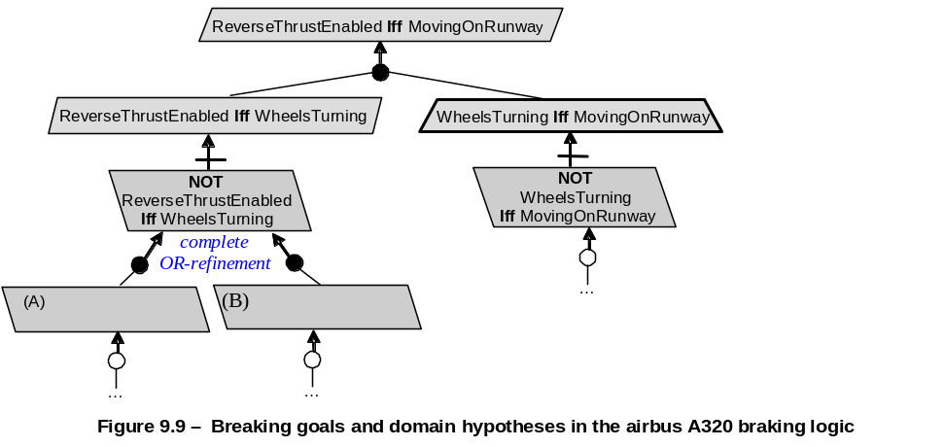  Sub obstacles (A) / (B) [file: Figure-9.9.jpg] in the Figure 9.9 should be.
a. | Not ReverseThrustEnabled / Not WheelsTurning
b. | ReverseThrustEnabled And Not WheelsTurning / WheelsTurning And Not ReverseThrustEnabled
c. | ReverseThrustEnabled IF WheelsTurning / WheelsTurning IF Not ReverseThrustEnabled
d. | None of the others
e.
f.
ANS: | B
PTS: | 1
CHAPTER: | 9
MIX CHOICES: | YES

QN=11 | Obstacles completeness can show about ______ and obstacle analysis may help elicit and validate relevant domain properties
a. | what we know about the domain and how adequate our knowledge is
b. | existential property capturing unadmissible behavior (negative scenario)
c. | obstacle analysis may help to validate relevant domain properties
d. | condition on system for violation of corresponding assertion
e.
f.
ANS: | a
PTS: | 1
CHAPTER: | 9
MIX CHOICES: | YES

QN=12 | Which of the following conditions is NOT a statement about an obstacle to an assertion need to meet?
a. | {not O1,..., not On, Dom } |= G
b. | {O, Dom } |= not G
c. | {O, Dom } not satisfied FALSE
d. | O can be satisfied by some system behavior
e.
f.
ANS: | a
PTS: | 1
CHAPTER: | 9
MIX CHOICES: | YES

QN=13 | OR-refinement of obstacle O should be, EXCEPT?
a. | {subOi, Dom } |= O
b. | {subOi, subOj, Dom } |= false
c. | {subO1,..., subOj-1, subOj+1 , ..., subOn, Dom } |= O
d. | {not subO1,..., not subOn, Dom } |= not O
e. | {subOi, Dom } not satisfied FALSE
f.
ANS: | c
PTS: | 1
CHAPTER: | 9
MIX CHOICES: | YES

QN=14 | An object model provides a _________ of the system-as-is and system-to-be.
a. | Intentional view
b. | Functional view
c. | structural view
d. | behavioral view
e.
f.
ANS: | C
PTS: | 1
CHAPTER: | 10
MIX CHOICES: | YES

QN=15 | A/an _________ is a discrete set of instances of a domain-specific concept that are manipulated by the modelled system
a. | System state
b. | State variable
c. | Object class
d. | Conceptual object
e.
f.
ANS: | D
PTS: | 1
CHAPTER: | 10
MIX CHOICES: | YES

QN=16 | The features shared by object instances include:
a. | common vocabularies, glossary of terms, object’s attributes and definition
b. | goals, agents, operations and behavior models
c. | object’s definition, type, individual attributes, associations, domain invariants
d. | None of the others
e.
f.
ANS: | C
PTS: | 1
CHAPTER: | 10
MIX CHOICES: | YES

QN=17 | An entity is ___________.
a. | An autonomous and active object
b. | A conceptual object dependent on other objects that it links.
c. | An instantaneous object
d. | None of the others
e.
f.
ANS: | D
PTS: | 1
CHAPTER: | 10
MIX CHOICES: | YES

QN=18 | The association is also called under synonymous term __________
a. | ‘relation’
b. | ‘relationship’
c. | ‘linked object’
d. | none of the others
e.
f.
ANS: | B
PTS: | 1
CHAPTER: | 10
MIX CHOICES: | YES

QN=19 | Each linked object in an association plays specific _____ in the association
a. | Relation
b. | Role
c. | Link
d. | none of the others
e.
f.
ANS: | B
PTS: | 1
CHAPTER: | 10
MIX CHOICES: | YES

QN=20 | The multiplicity on one side of an association specifies the minimum and maximum number of object instances on _______ that may be associated with one target object instance.
a. | the other side
b. | this side
c. | both sides
d. | None of the others
e.
f.
ANS: | B
PTS: | 1
CHAPTER: | 10
MIX CHOICES: | YES

QN=21 | An attribute is _______________.
a. | An intrinsic feature of an object regardless of other objects in the model
b. | A relevant feature of an object, including the association with other objects in the model
c. | A quantitative feature of an object
d. | none of the others
e.
f.
ANS: | A
PTS: | 1
CHAPTER: | 10
MIX CHOICES: | YES

QN=22 | A specialization link may be introduced in a model between an object SubOb and an object SuperOb if every current instance of _____ is a current instance of _____ as well.
a. | SuperOb / SubOb
b. | SubOb / SuperOb
c.
d.
e.
f.
ANS: | B
PTS: | 1
CHAPTER: | 10
MIX CHOICES: | YES

QN=23 | In specialization, the object SubOb plays the role ______ whereas the object SuperOb plays the inverse role ______.
a. | Generalizes / Specializes
b. | Specializes / Generalizes
c. | IsA / SubClassOf
d. | SubClassOf / IsA
e.
f.
ANS: | B
PTS: | 1
CHAPTER: | 10
MIX CHOICES: | YES

QN=24 | An______ link may be introduced between an object Ob and objects PartOb1,… PartObn if every current instance of Ob is a tuple of current instances of PartOb1, …., PartObn.
a. | aggregation
b. | composition
c. | association
d. | combination
e.
f.
ANS: | a
PTS: | 1
CHAPTER: | 10
MIX CHOICES: | YES

QN=25 | _______ is a particular case of aggregation whether the composite object Ob and its parts PartObi appear and disappear together in the system.
a. | aggregation
b. | composition
c. | association
d. | combination
e.
f.
ANS: | b
PTS: | 1
CHAPTER: | 10
MIX CHOICES: | YES

QN=26 | Agent instances have individual behaviors captured by sequence of state transitions for the _________ that they control. These variables refer to attributes/associations of object instances.
a. | state variables
b. | system state variables
c. | system object variables
d. | object attributes
e.
f.
ANS: | A
PTS: | 1
CHAPTER: | 10
MIX CHOICES: | YES

QN=27 | An agent model captures the ____-dimension of requirements engineering
a. | WHY
b. | WHO
c. | WHAT
d. | HOW
e.
f.
ANS: | B
PTS: | 1
CHAPTER: | 11
MIX CHOICES: | YES

QN=28 | An agent is an ______ system component play a role in goal satisfaction.
a. | Active
b. | Passive
c. | Instantaneous
d. | none of the others
e.
f.
ANS: | A
PTS: | 1
CHAPTER: | 11
MIX CHOICES: | YES

QN=29 | Which of the following statements about agent capabilities is wrong?
a. | An agent monitors an attribute of an object if its instances can get the value of this attribute from object instances
b. | An agent monitors an association if its instances can control this association holds between object instances
c. | An agent controls an attribute of an object if its instances can set values for this attribute on object instances
d. | An agent controls an association if its instances can create and delete association instances
e.
f.
ANS: | B
PTS: | 1
CHAPTER: | 11
MIX CHOICES: | YES

QN=30 | A goal under the responsibility of an agent must be realizable by the agent in view of its ________.
a. | Responsibilities
b. | Capabilities
c. | Realizabilities
d. | None of the others
e.
f.
ANS: | B
PTS: | 1
CHAPTER: | 11
MIX CHOICES: | YES

QN=31 | Agent capabilities are defined in terms of the system variables that the agent can _____ and _____.
a. | Assign / evaluate
b. | Specify / realize
c. | Monitor / control
d. | none of the others
e.
f.
ANS: | C
PTS: | 1
CHAPTER: | 11
MIX CHOICES: | YES

QN=32 | 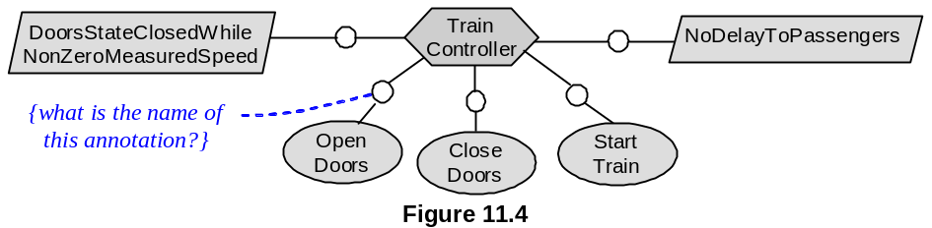  In figure 11.4 [file: Figure-11.4.jpg], what is the name of the annotation attached to the link between the agent and the operation in the agent model?
a. | Responsibility instance declaration
b. | Capability instance declaration
c. | Performance instance declaration
d. | none of the others
e.
f.
ANS: | C
PTS: | 1
CHAPTER: | 11
MIX CHOICES: | YES

QN=33 | Which of the following statements is the definition of “capability instance declaration” (CID)?
a. | It annotating a performance link in an agent diagram makes precise which agent instance is performing the operation on which input/output object instance
b. | It annotating a monitoring or control link makes precise which agent instance is monitoring or controlling the attribute/association of which object instance
c. | It annotating a responsibility link in an agent diagram makes it precise which agent instance is responsible for which goal instantiation to specific object instances
d. | None of the others
e.
f.
ANS: | B
PTS: | 1
CHAPTER: | 11
MIX CHOICES: | YES

QN=34 | In the agent model, an agent ag1 is said to depend on another agent ag2 for a goal G under the responsibility of ag2, if ___’s failure to get G satisfied can result in ___’s failure to get one of its assigned goals satisfied
a. | ag1 / ag2
b. | ag2 / ag1
c.
d.
e.
f.
ANS: | B
PTS: | 1
CHAPTER: | 11
MIX CHOICES: | YES

QN=35 | What is an agent-goal co-refinement process?
a. | A process in which an agent and its assigned goals are refined in parallel into finer-grained agents, sub-goals and responsibility assignments
b. | A process in which agents and assigned goals are generalized in parallel into coarse-grained agents and abstract goals
c. | Both of above statements are wrong
d.
e.
f.
ANS: | A
PTS: | 1
CHAPTER: | 11
MIX CHOICES: | YES

QN=36 | 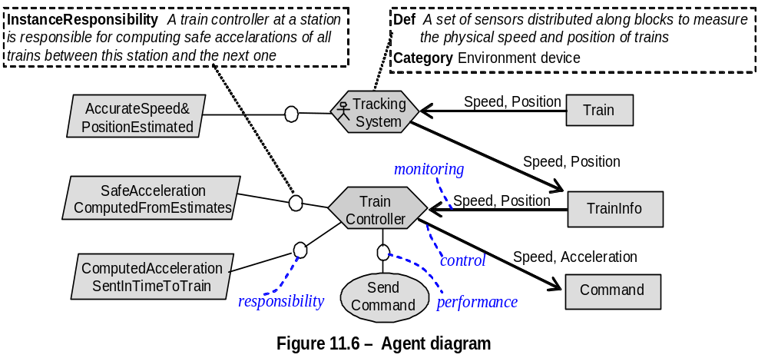  In figure 11.6 [file:Figure-11.6.jpg], “Train” and “TrainInfo” are classified as
a. | Agents
b. | Events
c. | Entities
d. | Associations
e.
f.
ANS: | C
PTS: | 1
CHAPTER: | 11
MIX CHOICES: | YES

QN=37 | Which of the following is NOT a rule for agent responsibility when building agent model?
a. | Assignment to wisher
b. | Assignment refinement
c. | Assignment based on goal-capability matching
d. | Assignment selection based on achieve goal
e.
f.
ANS: | D
PTS: | 1
CHAPTER: | 11
MIX CHOICES: | YES

QN=38 | A goal turns to be unrealizable by an agent if and only if one of the following criteria hold, EXCEPT?
a. | The agent is unable to control a variable in the goal specification that needs to be constrained for goal satisfaction.
b. | There is a variable in the goal specification that needs to be evaluated in a future state.
c. | An external circumstance can make the goal unsatisfiable.
d. | The goal is a bounded Achieve goal; that is, its target condition can be definitely postponed to future states.
e.
f.
ANS: | D
PTS: | 1
CHAPTER: | 11
MIX CHOICES: | YES

QN=39 | Which of the following can we base on to build system architecture and to understand the interface between system components?
a. | Goal model
b. | Object model
c. | Obstacles model
d. | Agent model
e. | Behavioral model
f.
ANS: | D
PTS: | 1
CHAPTER: | 11
MIX CHOICES: | YES

QN=40 | A/An ________ designates an object instance to which the operation applies. The state of this instance affects the application of the operation.
a. | State variable
b. | Input variable
c. | Out variable
d. | None of the others
e.
f.
ANS: | B
PTS: | 1
CHAPTER: | 12
MIX CHOICES: | YES

QN=41 | A particular application of the operation yields a state _______ from a state in InputState to a state in OutputState.
a. | transformation
b. | exchange
c. | transition
d. | none of the others
e.
f.
ANS: | C
PTS: | 1
CHAPTER: | 12
MIX CHOICES: | YES

QN=42 | Domain pre- and post-conditions are prescriptive.
a. | True
b. | False
c.
d.
e.
f.
ANS: | B
PTS: | 1
CHAPTER: | 12
MIX CHOICES: | YES

QN=43 | The specification of an operation therefore includes a set of prescriptive conditions on operation applications. These conditions are aimed at ensuring that ______.
a. | the operation is dependent on the goals
b. | the goals underlying the operation are satisfied
c. | the operation associates with the goals
d. | None of the others
e.
f.
ANS: | B
PTS: | 1
CHAPTER: | 12
MIX CHOICES: | YES

QN=44 | Which of the following statements about required condition is true?
a. | Required pre-condition captures an obligation.
b. | Required trigger condition captures an additional effect.
c. | Required post-condition captures a permission.
d. | none of the others
e.
f.
ANS: | D
PTS: | 1
CHAPTER: | 12
MIX CHOICES: | YES

QN=45 | The operation is not applied if a trigger condition becomes true in a state where the operation’s domain pre-condition is not true.
a. | True
b. | False
c.
d.
e.
f.
ANS: | A
PTS: | 1
CHAPTER: | 12
MIX CHOICES: | YES

QN=46 | Which of the following statements is false?
a. | An operation may operationalizes multiple goals.
b. | A goal may be operationalized by multiple operations.
c. | Multiple agents perform an operation.
d. | An agent may perform multiple operations.
e.
f.
ANS: | C
PTS: | 1
CHAPTER: | 12
MIX CHOICES: | YES

QN=47 | An operationalization diagram is an annotated graph showing the system operations, their ______ to goals in the goal model and input/output links to objects in the object model.
a. | performance links
b. | operationalization links
c. | capability links
d. | None of the others
e.
f.
ANS: | B
PTS: | 1
CHAPTER: | 12
MIX CHOICES: | YES

QN=48 | A use case diagram provides an outline view of an operation model by showing the operations that an agent performs together with ________ with other agents.
a. | interaction links.
b. | responsibility links
c. | operationalization links
d. | None of the others
e.
f.
ANS: | A
PTS: | 1
CHAPTER: | 12
MIX CHOICES: | YES

QN=49 | In _______ scheme, the agent instance applies the operation when it is really obliged to do so; that is, when one of the operation’s required trigger conditions becomes true.
a. | an eager behaviour
b. | a lazy behaviour
c.
d.
e.
f.
ANS: | B
PTS: | 1
CHAPTER: | 12
MIX CHOICES: | YES

QN=50 | Which of the following designates an object instance on which the operation acts (The state of this instance is changed by the application of the operation.)?
a. | An input variable
b. | An output variable
c. | State variables
d. | Instance variables
e.
f.
ANS: | B
PTS: | 1
CHAPTER: | 12
MIX CHOICES: | YES

QN=51 | An operation model may be used for the following purposes, EXCEPT?
a. | The model part covering software-to-be operations yields software specifications for input to the development process.
b. | The model part covering environment operations yields provides descriptions of tasks and procedures to be jointly performed in the environment for satisfaction of the system's goals.
c. | Black-box test data and executable specifications for system animation or software prototyping can be derived from an operation model.
d. | An operation model may also serve as an input to detailed design stage.
e.
f.
ANS: | D
PTS: | 1
CHAPTER: | 12
MIX CHOICES: | YES

QN=52 | Which of the following is a condition on the operation's output states to ensure a goal? This condition captures an additional effect that the operation must have specifically to ensure the goal.
a. | Domain pre-condition
b. | Required post-condition
c. | Required pre-condition
d. | Required trigger condition
e.
f.
ANS: | B
PTS: | 1
CHAPTER: | 12
MIX CHOICES: | YES

QN=53 | Which of the following is a sufficient condition on the operation's input states to ensure a goal when domain pre-condition is true, operation must be applied as soon as it is true?
a. | Domain pre-condition
b. | Domain post-condition
c. | Required pre-condition
d. | Required trigger condition
e.
f.
ANS: | D
PTS: | 1
CHAPTER: | 12
MIX CHOICES: | YES

QN=54 | Which of the following is a necessary condition on the operation's input states to ensure a goal when domain pre-condition is true, operation may be applied only if this condition is true?
a. | Domain pre-condition
b. | Domain post-condition
c. | Required pre-condition
d. | Required trigger condition
e.
f.
ANS: | C
PTS: | 1
CHAPTER: | 12
MIX CHOICES: | YES

QN=55 | A goal G is correctly operationalized into Op1, …,Opn if and only if the specification Spec(Op1), …, Spec(Opn) of these operations in term of domain and required conditions are necessary and sufficient for ensure G; that are the following, EXCEPT?
a. | {Spec(Op1), …, Spec(Opn) } |= G
b. | {Spec(Op1), …, Spec(Opn) } not satisfied False
c. | G |= {Spec(Op1), …, Spec(Opn) }
d. | {Spec(Op1), …, Spec(Opn) } |= false
e.
f.
ANS: | D
PTS: | 1
CHAPTER: | 12
MIX CHOICES: | YES

